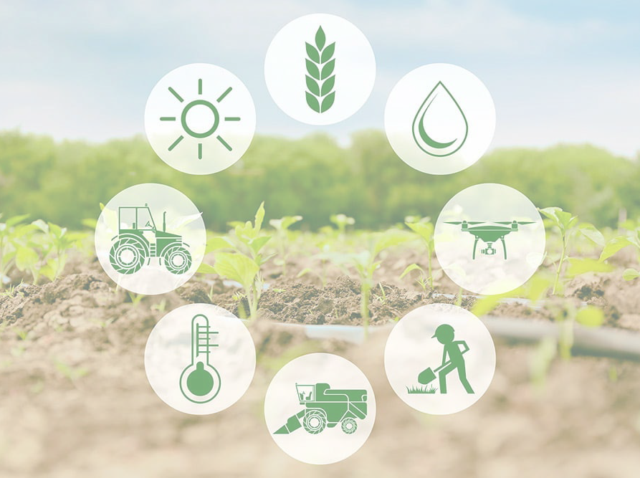
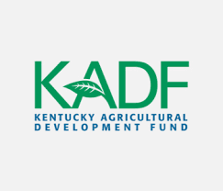




Youth Agricultural Incentives Program
Edmonson County 4-H Council

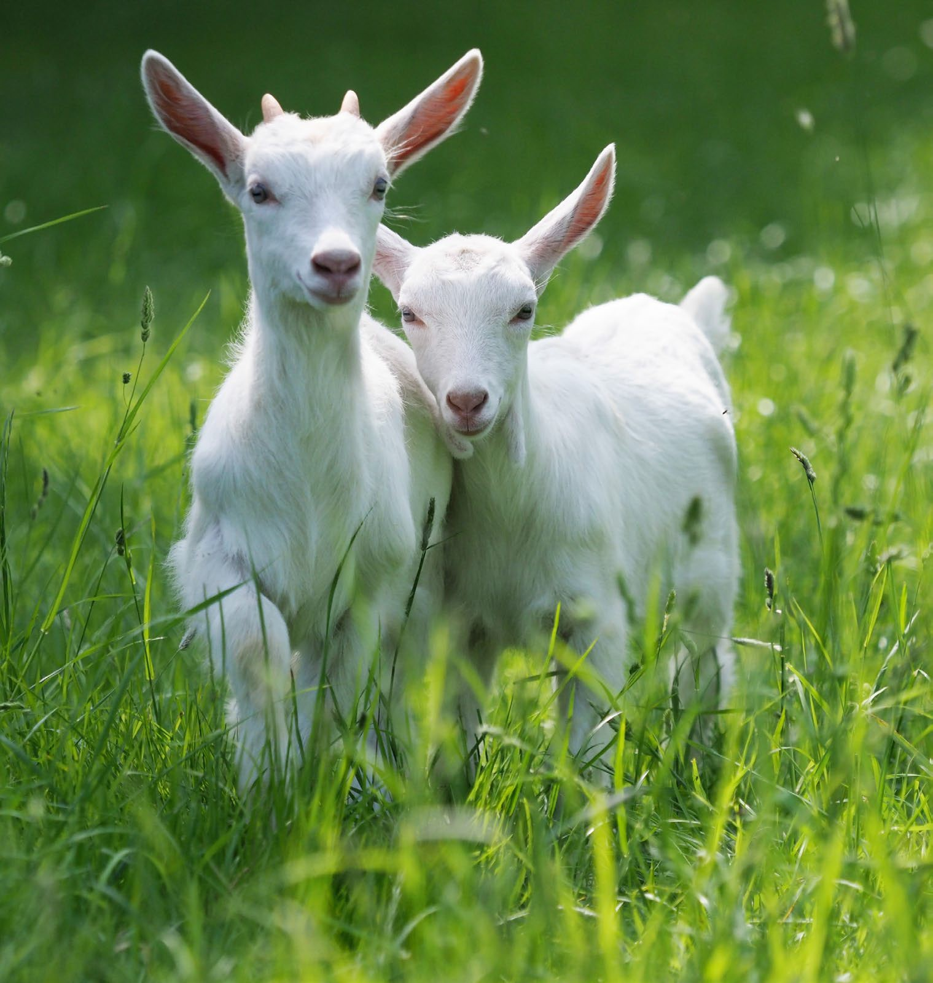
Purpose
of the Program
The Youth Agricultural Incentives Program was established to facilitate a growing need for a specialized program that would benefit youth ages 9-18 actively engaged in agriculture.
The focus of the program will be on youth developing agricultural projects, as well as strengthening partnerships with school ag programs, Cooperative Extension, and 4-H/FFA organizations.

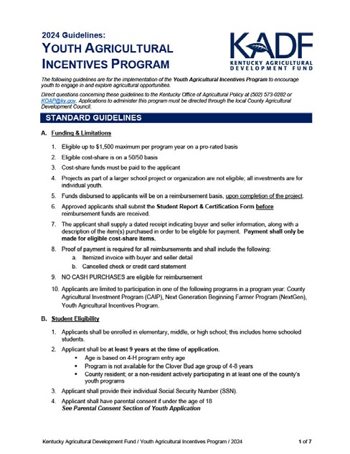

STANDARD GUIDELINES

Guidelines & Eligibility

Funding & Limitations
- Eligible up to $1,500 maximum program year on a pro-rated basis depending on number of approved applicants.
- Eligible cost-share is on a 50/50 basis.
- Cost-share funds must be paid to the applicant.
- Projects as part of a larger school project or organization are not eligible; all investments are for individual youth.
- Funds disbursed to applicants will be on a reimbursement basis, upon completion of the project.
- Approved applicants shall submit the Student Report & Certification Form before reimbursement funds are received.
- The applicant shall supply a dated receipt indicating buyer and seller information, along with a description of the item(s) purchased to be eligible for payment. Payment shall only be made for eligible cost-share items.
- Proof of payment is required for all reimbursements and shall include the following:
Itemized invoice with buyer and seller detail
Cancelled check or credit card statement
- NO CASH PURCHASES are eligible for reimbursement
- Applicants are limited to participation in one of the following programs in a program year: County Agricultural Investment Program (CAIP), Next Generation Beginning Farmer Program (NextGen), Youth Agricultural Incentives Program.
Each student who receives $600 or more shall be supplied an IRS form 1099 or equivalent tax accounting documentation.

Guidelines & Eligibility

Student Eligibility
  - Applicants shall be enrolled in elementary, middle, or high school; this includes home schooled students.
  - Applicant shall be at least 9 years at the time of application.
Age is based on 4-H program entry age.
Program is not available for the Clover Bud age group of 4- 8 years.
County resident; or a non- resident actively participating in at least one of the county’s youth programs.

  - Applicant shall provide their individual Social Security Number (SSN).
  - Applicant must have parental consent if under the age of 18. See Parental Consent Section of Youth Application
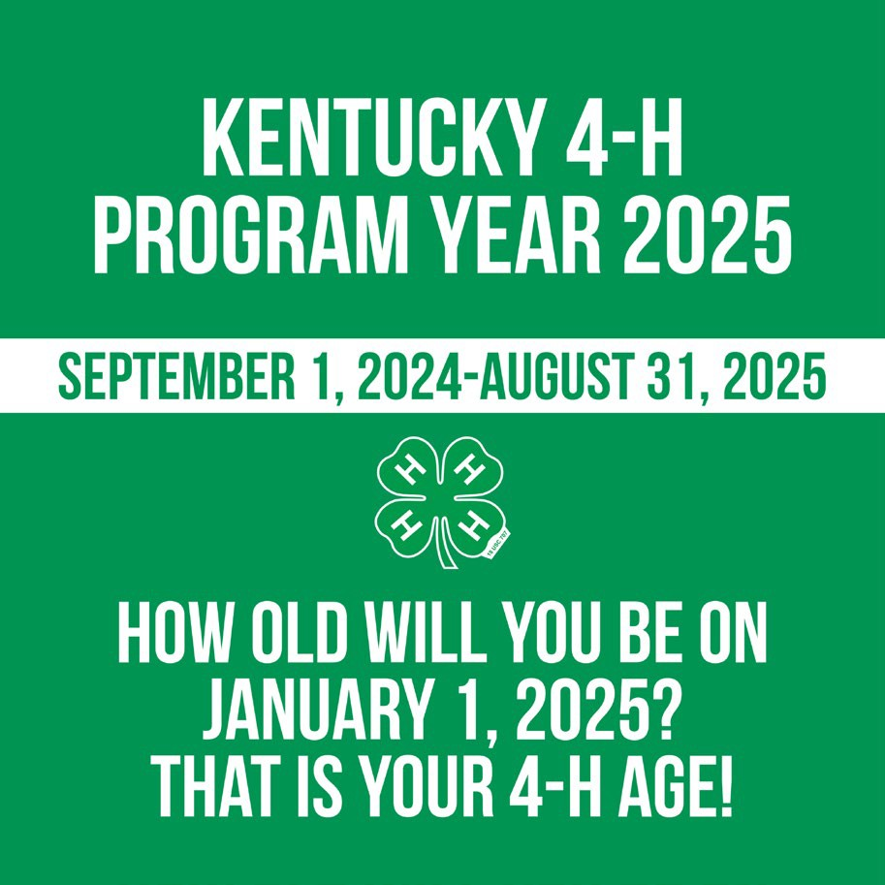

Guidelines & Eligibility

Mentorship

- Mentorship is required from one of the following types of organizations:
4-H Leader or Extension Agent FFA Leader or Ag Teacher
Mentors must be willing to provide consultation or assistance for the length of the program and shall not be from the applicant’s immediate family.
Youth unable to secure a mentor not in 4-H can join 4-H and become mentored by a current club leader or volunteer in good standing.
- Applicant shall complete one of the following:
Make a presentation to their mentor and peers related to the approved project(s).
Organize one (1) event in partnership with 4-H or FFA relative to the following:
  - Community service event
  - Workshop or field day
- Applicant shall complete at least one educational component – minimum of two (2) hours total - from one of the following:
4-H club education – specific to investment area.
FFA program education – specific to investment area.
Leadership or Community Service.
Marketing or Promotion.

Education must be approved by the applicant’s designated mentor.

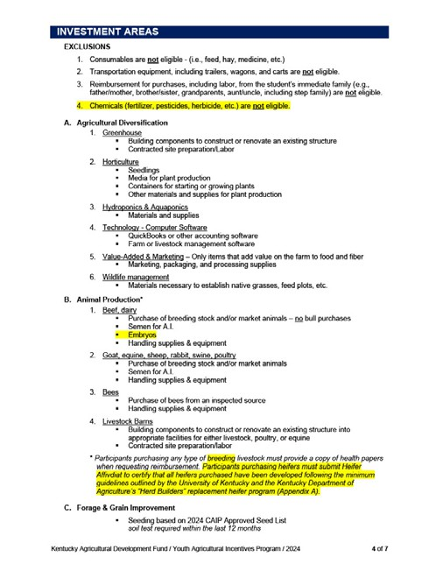

INVESTMENT AREAS
Choose 2



Investment Areas

Agriculture Diversification

Greenhouse Construction or Conversion
- Building Components to construct or renovate an existing structure, contracted site preparation/labor

Horticulture
- Seedlings, media for plant production, containers for starting or growing plants, other materials and supplies for plant production

Hydroponics & Aquaponics
- Materials and supplies

Technology – Computer Software
- QuickBooks or other accounting software; farm or livestock management software

Value-Added & Marketing
- Marketing, packaging, and processing supplies

Wildlife Management
- Materials necessary to establish native grasses, feed plots, etc.

Beef, Dairy

Investment Areas

Animal Production
Bees

- Purchase of breeding stock and/or market animals – no bull purchases.
- Semen for A.I.
- Embryos
- Handling supplies & equipment.
Goat, Equine, Sheep, Rabbit, Swine, Poultry
- Purchase of breeding stock and/or market animals.
- Semen for A.I.
- Handling supplies & equipment.
- Purchase of bees from an inspected source.
- Handling supplies & equipment.
Livestock Barns
- Building components to construct or renovate an existing structure into appropriate facilities for either. livestock, poultry, or equine
- Contracted site preparation/labor.
Participants purchasing any type of breeding livestock must provide a copy of health papers when requesting reimbursement. Participants purchasing heifers must submit Heifer Affidavit to certify that all heifers purchased have been developed following the minimum guidelines outlined by the University of Kentucky and the Kentucky Department of Agriculture’s “Herd Builders” replacement heifer program (Appendix A).


Investment Areas

Forage & Grain Improvement

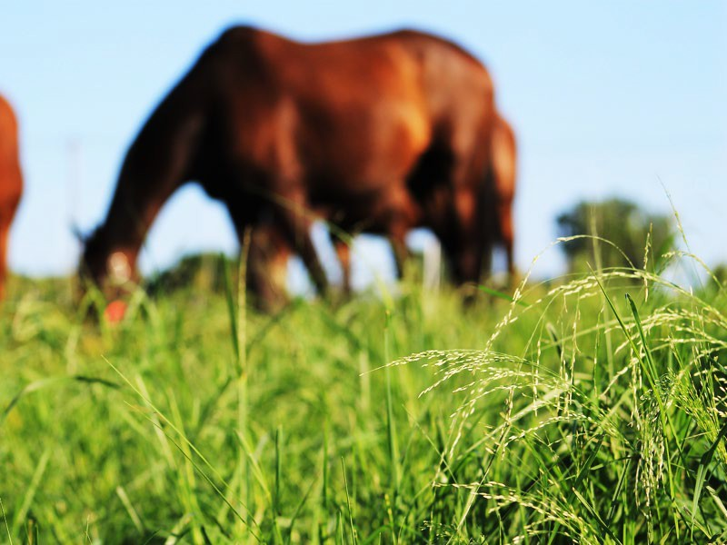
Seeding
  - based on 2024 CAIP Approved Seed List
  - Soil test required within the last 12 months
    - Contact Edmonson County Extension for soil testing guidelines and instructions.

Investment Areas

Showmanship

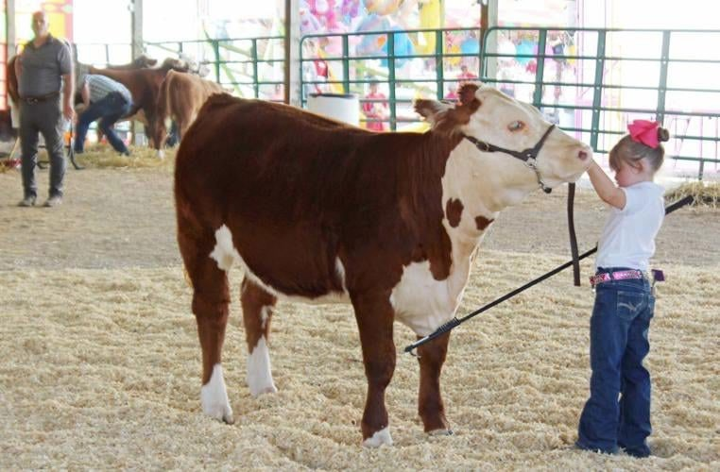
Beef, Dairy, Equine, Goat, Sheep, Swine, Poultry, Rabbit
  - Showmanship equipment & supplies, including a generator.
  - Handling supplies & equipment.

Participants purchasing any type of breeding livestock must provide a copy of health papers when requesting reimbursement. Participants purchasing heifers must submit Heifer Affidavit to certify that all heifers purchased have been developed following the minimum guidelines outlined by the University of Kentucky and the Kentucky Department of Agriculture’s “Herd Builders” replacement heifer program (Appendix A).

Investment Areas


Country Ham Projects

Country Ham Projects
  - Ham purchase
  - Project supplies
  - Cost of participation in a 4-H Country Ham Project

Investment Areas

EXCLUSIONS

Consumables
Feed Hay
Medicine Etc.
Transportation equipment Trailers
Wagons Carts
Chemicals
Fertilizer Pesticides Herbicide Etc.
Labor from the student’s immediate family father/mother
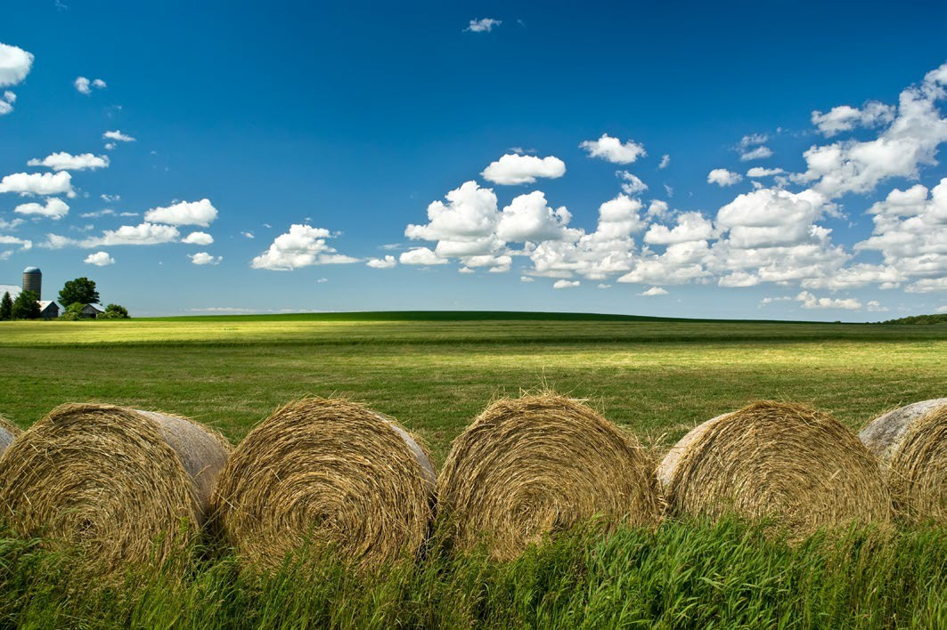
brother/sister Grandparents aunt/uncle including stepfamily

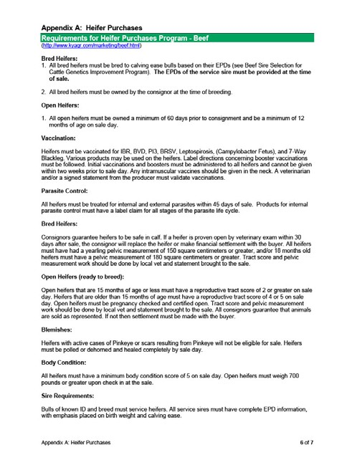

APPENDIX
HEIFER REQUIREMENTS

Appendix

Heifer Requirements-Beef
Bred Open

All bred heifers must be bred to calving ease bulls based on their EPDs
See Beef Sire Selection for Cattle Genetics Improvement Program. http://afs.ca.uky.edu/beef/KBAT
Heifer Acceptable Balanced Trait
The EPDs of the service sire must be provided at the time of sale.
All bred heifers must have been owned by the consignor at the time of breeding.

All open heifers must have been owned a minimum of 60 days prior to consignment and be a minimum of 12 months of age on sale day.
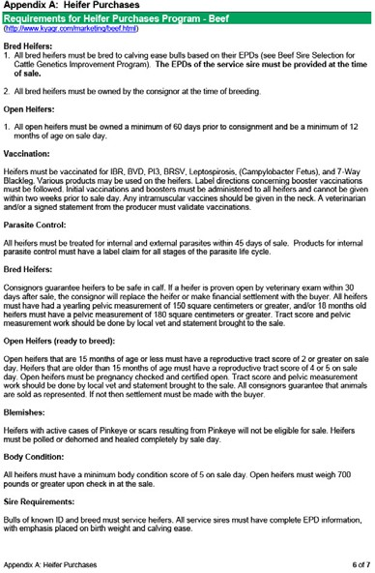
Open heifers should be pregnancy checked and certified open. Tract score and pelvic measurement work should be done by local vet.

Appendix

Heifer Requirements-Dairy
Bred Open

All bred heifers should be bred AI to bulls that are considered acceptable to use on heifers based upon scoring <10% on percentage of difficult births in heifers (%DBH).
All bred heifers must have been owned by the consignor at the time of breeding.

All open heifers must have been owned a minimum of 60 days prior to consignment and be a minimum of 12 months of age on sale day.
Open heifers should be pregnancy checked and certified open. Tract score and pelvic measurement work should be done by local vet.

Appendix

Vaccines & Parasite Control
Vaccines Parasite Control

Heifers must be vaccinated for:
IBR, BVD, PI3, BRSV, Leptospirosis, and 7-Way Blackleg.
Various products may be used on the heifers.
Label directions concerning booster vaccinations must be followed.
Initial vaccinations and boosters must be administered to all heifers and cannot be given within two weeks prior to sale day.
A veterinarian and/or a signed statement from the producer must validate vaccinations.
All vaccinations must meet BQA certification and must include a list of all products used.
All heifers must be treated for internal and external parasites within 45 days of sale.
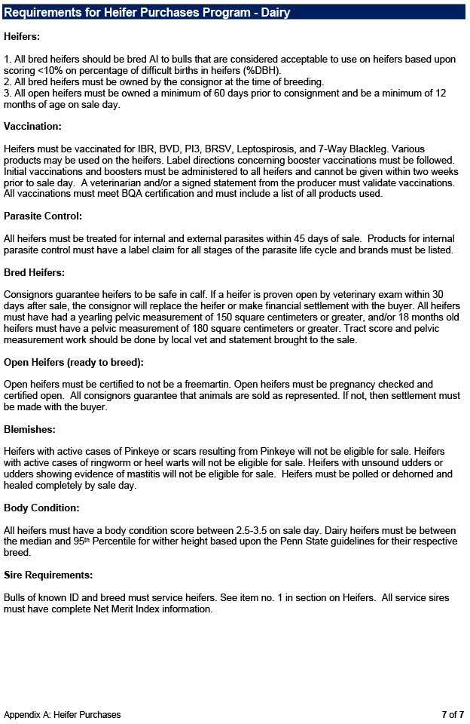
Products for internal parasite control must have a label claim for all stages of the parasite life cycle and brands must be listed.

PROGRAM TIMELINES


Program Timelines

APPLICATION PERIOD
- November 4-December 2, 2024 @4:00pm

PROGRAM PERIOD
- September 1, 2024-June 30,
2025 @4:00pm

6 MO. CHECK-IN MEETING
- Youth and a parent/guardian must schedule a check-in meeting with the program administrator in February for a mid-year project review unless project has been completed.
- Youth should be in contact with their mentors more often than this during the duration of the project.

PROGRAM DEADLINE
- All funds must be spent and the Student Report & Certification Form submitted with receipts and documentation by June 30, 2025.
- Receipts can be retroactive to September 1, 2024, for purchases made by the youth for their project.
  - Must be pre-approved by program administrator prior to submission.

Failure to comply with guidelines and deadlines can result in forfeiture of program funds and eligibility for the next year.

Project Completion

Student Report & Certification Form completed entirely.
Receipts, invoices, proofs of payment
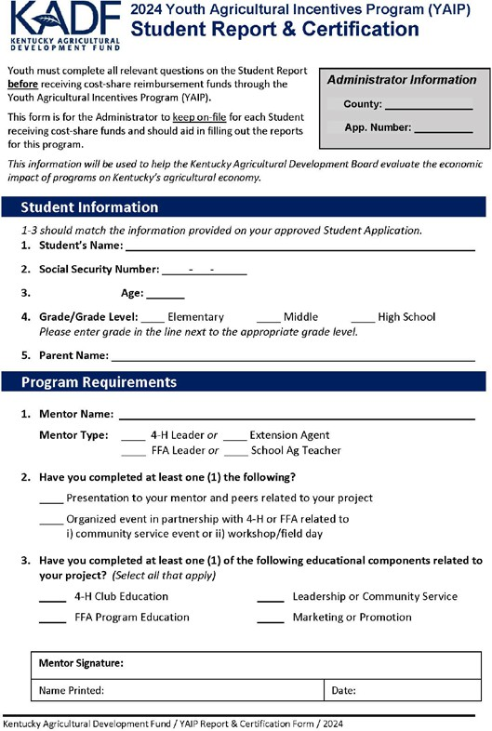
Photo documentation of project Site visit scheduled for all projects except Country Ham project.
Animal Production & Showmanship Documentation
Health papers Heifer Affidavit
Vaccination/Parasite documentation Bull service EPD’s and category for
bred heifers
Vet records
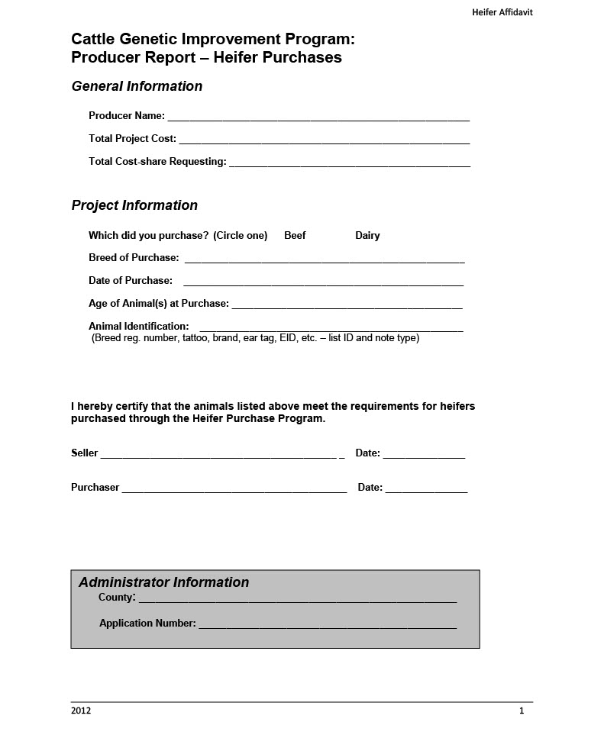
Pelvic measurements Reproductive
tract score
Confirmation of pregnancy

Application Information
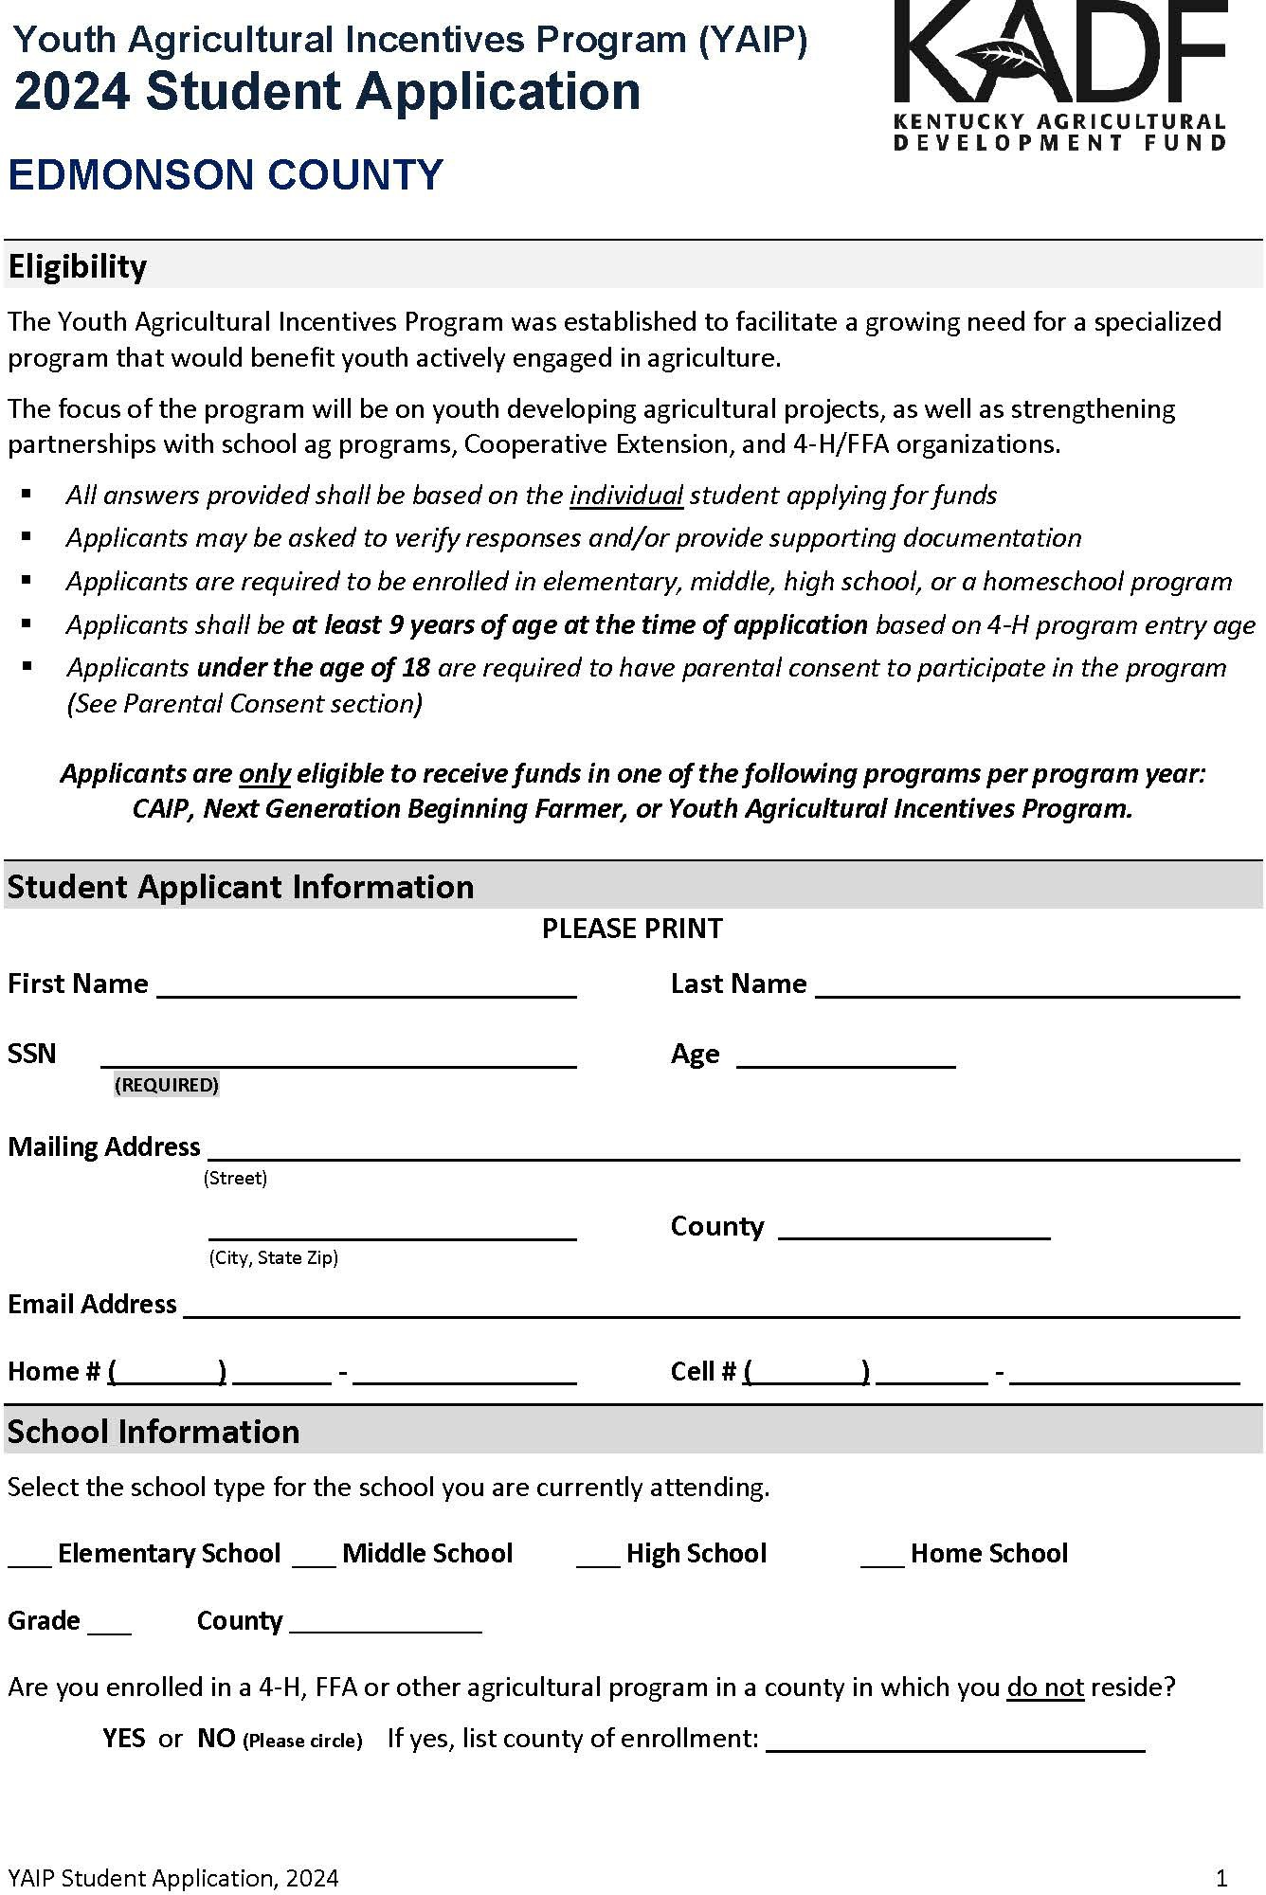
Application available online or for pick-up!
https://edmonson.ca.uky.edu The Edmonson County Cooperative Extension Office (in-person)
116 Mohawk St. Brownsville, KY

Supplemental Resources will be posted online by November 4, 2024, or paper copies of resources can be picked up at the Extension Office during office hours (8:00am-4:00pm).
APPLICATION DUE DECEMBER 2, 2024, at 4:00pm!

Bridgett Poteet

Program Administrators

bridgett.poteet@kysu.edu –best way to communicate with me
270-597-3628- office
270-246-2772- text

County 4-H Agent

Tracy Mitchell
Co-administrator & Signer

Edmonson County 4-H Council

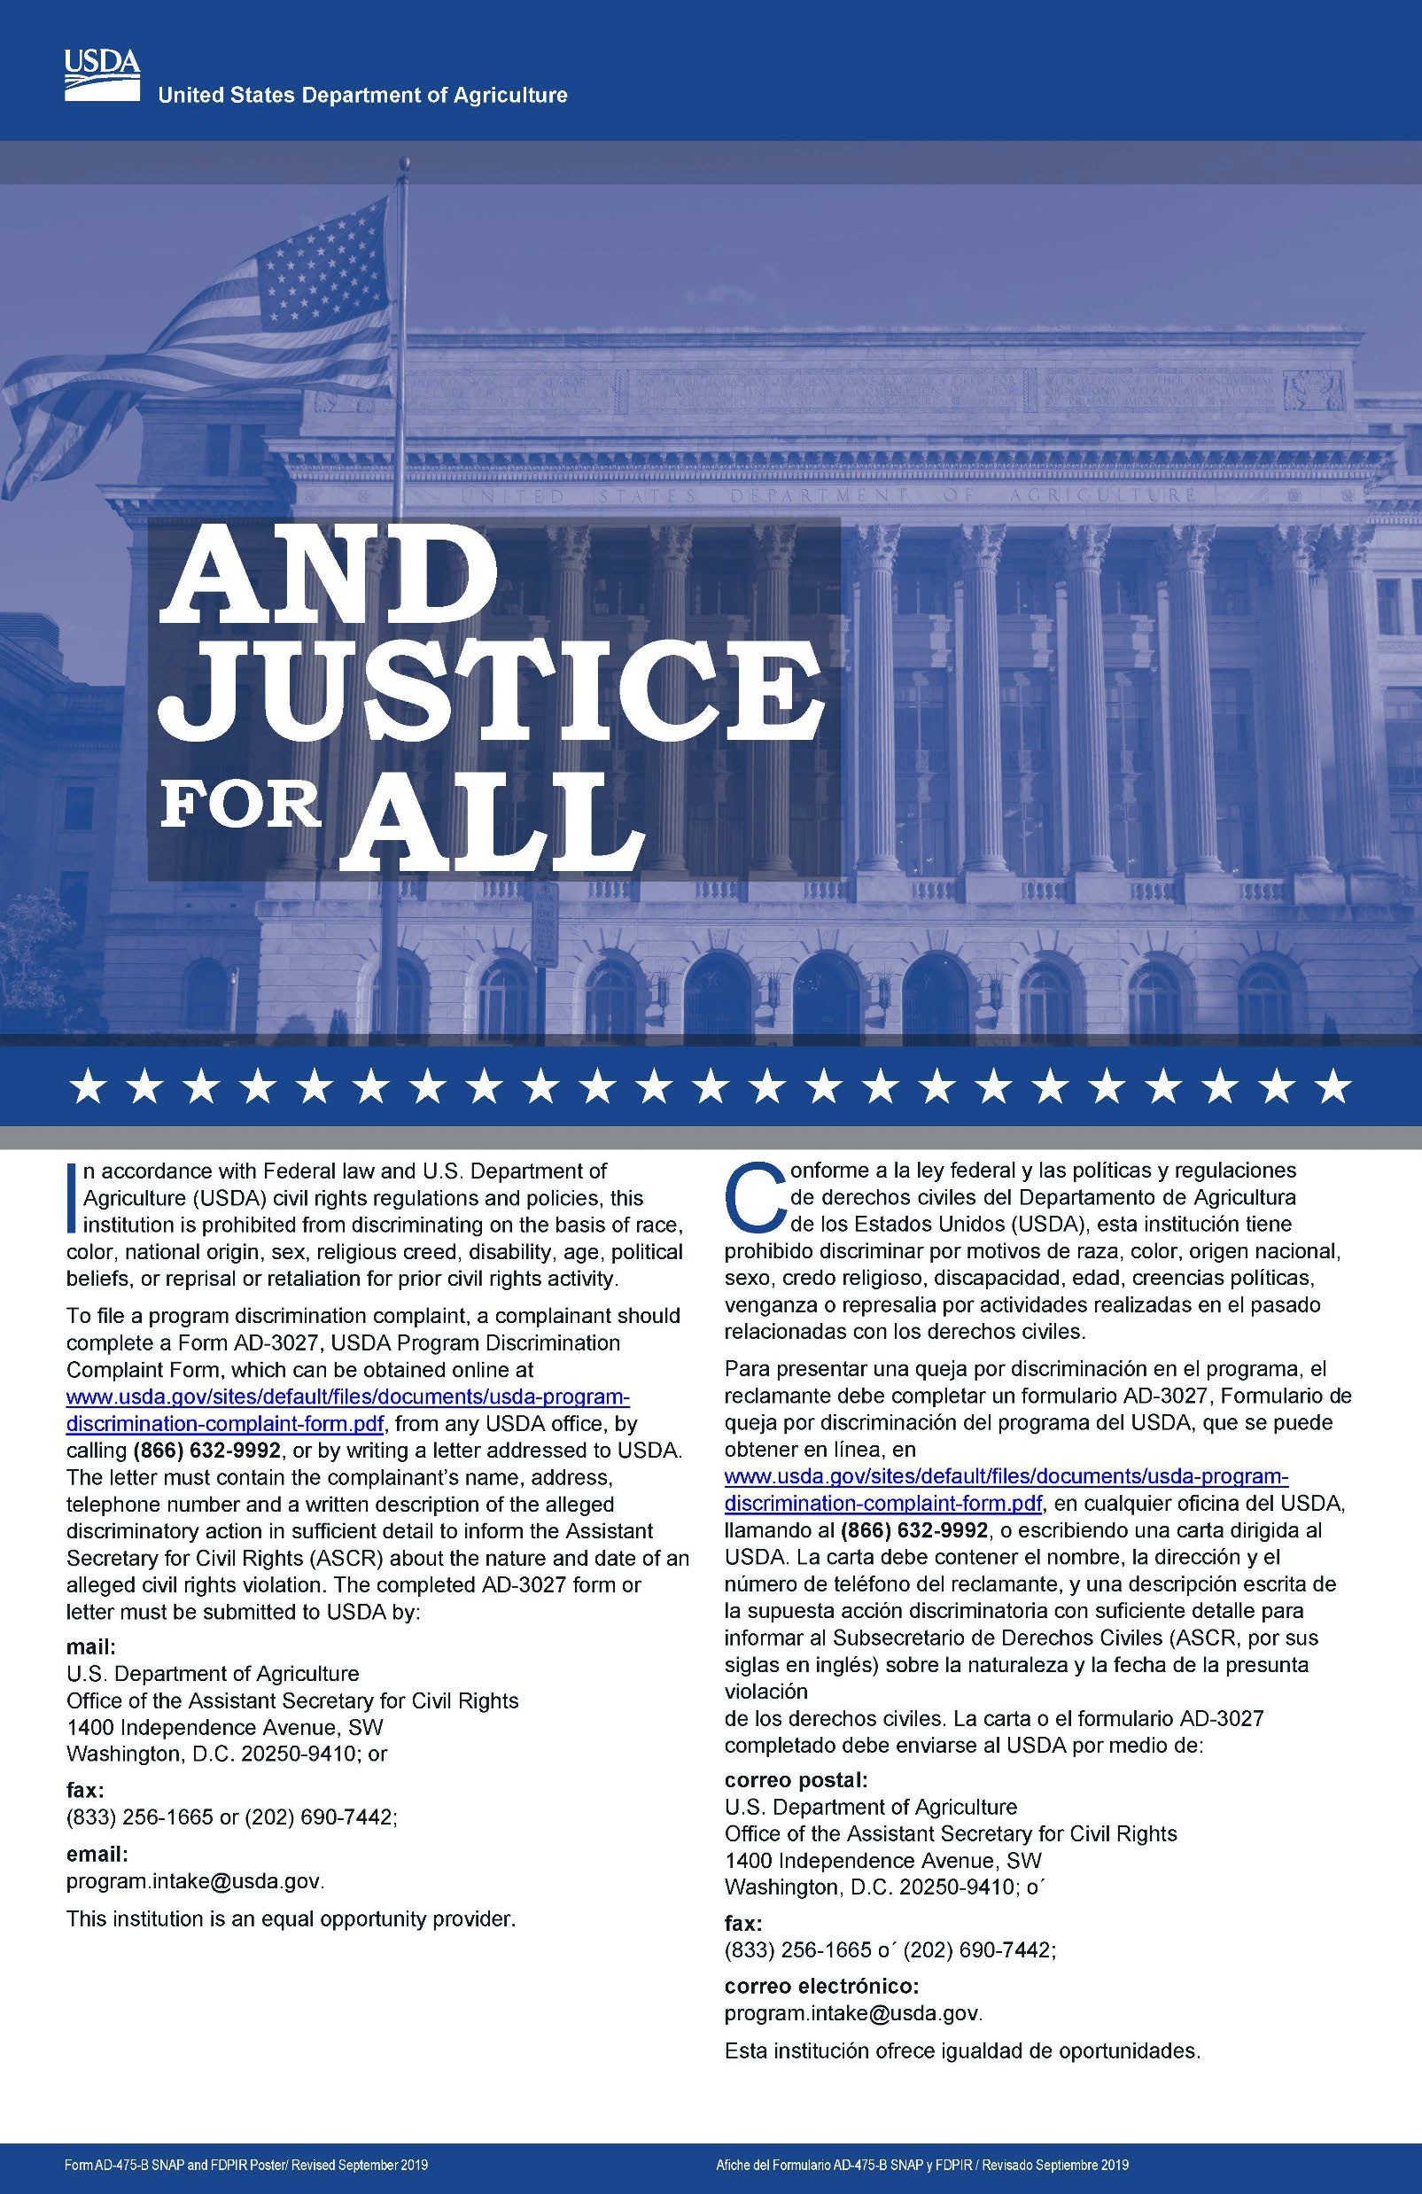
Reasonable Accommodation for Individuals with Disabilities
This institution is committed to providing equal opportunity for individuals with disabilities. We will make all reasonable efforts to provide auxiliary aids free of charge where necessary to ensure effective communication with individuals with hearing, vision, or speech impairments. Our goal is to ensure that individuals with disabilities have equal and effective opportunity to participate in or benefit from programs, activities, services, and resources in the most integrated setting possible.
In compliance with the Americans with Disabilities Act, Kentucky State University will honor requests for reasonable accommodations made by individuals with disabilities. Please direct requests for accommodations to: Event Coordinator’s name, title, email, and phone number. Requests can be served more effectively if notice is provided at least 10 days before the event.
If you need a reasonable accommodation to participate in this event, please contact Bridgett Poteet, at bridgett.poteet@kysu.edu or 270-597-3628 and no later than
November 15, 2024. Language access services, such as interpretation or translation of vital information, will be provided free of charge to limited English

